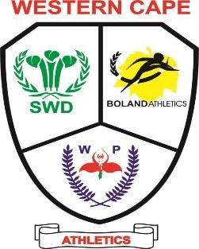

**CHAIRPERSON: MR B. DU PLESSIS SECRETARY: MS. F. CASSIEM**

**10 March 2024**

**SASA NATIONAL HIGH SCHOOLS ATHLETICS CHAMPIONSHIPS**

**DAL JOSAPHAT STADIUM, PAARL 3 – 6 APRIL 2024**

**Dear Regional, District Chairperson/ Principals/ Parents**

Congratulations to all the selected athletes.

Please be advised that the SASA National High Schools Athletics Championships will be held at the Dal Josaphat Stadium, Paarl 3 -6 April 2024. Further details regarding transport and accommodation will be provided.

Attached please find team list.

We would like to convey our sincere appreciation and gratitude is extended to the Department of Cultural Affairs and Sport as well as the Western Cape Education Department for the support provided to our athletes.

Transport and accommodation will be provided xxxxx(own bedding and toiletries are essential)

Please indicate the following:

My son/daughter athlete will be travelling and staying with the team – YES. NO

My son/daughter athlete will be staying/ not staying with the team

Please be advised of the following:  
1. Transport, accommodation and refreshments will be provided by the DCAS.

2. Clothing (tracksuits, running gear, tshirts, etc.) for athlete’s cost.

Athletes should have fitted and ordered the required competition attire which includes the Western Cape tracksuit and running gear. (All attire arrangements must be made directly with the service providers)

**Clothing**

Fieka Sport- 021 9291130

Tracksuits R 800.00

Tshirts R 350-00

**Running Gear** (Graham Van As -082 9757952)

Vest R 190.00  
Shorts R 150.00  
Tights R 150.00

**Pick up points for regions and districts on Tuesday 3 April 2024,**

|  |  |  |
| --- | --- | --- |
| **Region/ District** | **Pick up Points** | **Time of departure** |
| WP |  |  |
| Boland |  |  |
| Eden |  |  |
| Central Karoo |  |  |

Please complete the information form using the link below.

https://forms.gle/VajZKbST3BGZWg3J6

It is compulsory for those athletes not making use of the travelling and accommodation to report to the Western Cape Team Management at the stadium 1h30min before their event.

**Kind Regards**

**F. Cassiem**

**(General Secretary)**